Cleaning Work Order Template  A blank template can be found on page two. | 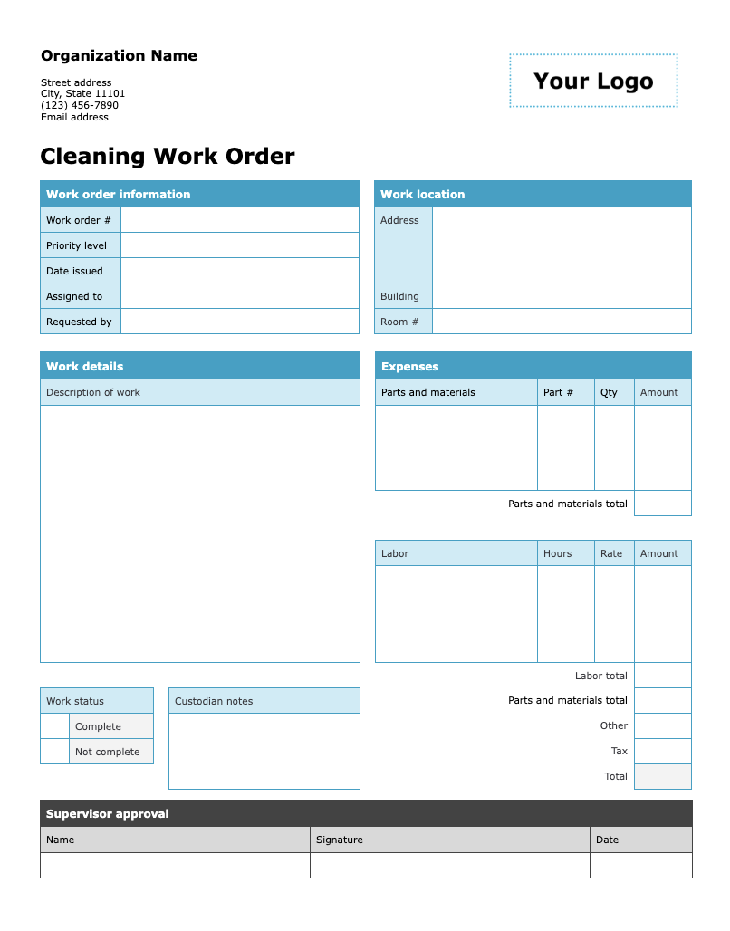

Follow these steps to get started

- Update the organization information by replacing the placeholder text with your organization's name, address, phone number, and email address.
- Add your logo by clicking on “Your Logo.” Then go to Insert > Picture and select the file you want to upload. The new image will automatically replace the placeholder.
- Adjust the fields and options on the form as needed.
- Remove this instruction page and distribute a copy to your colleagues to fill out and submit.

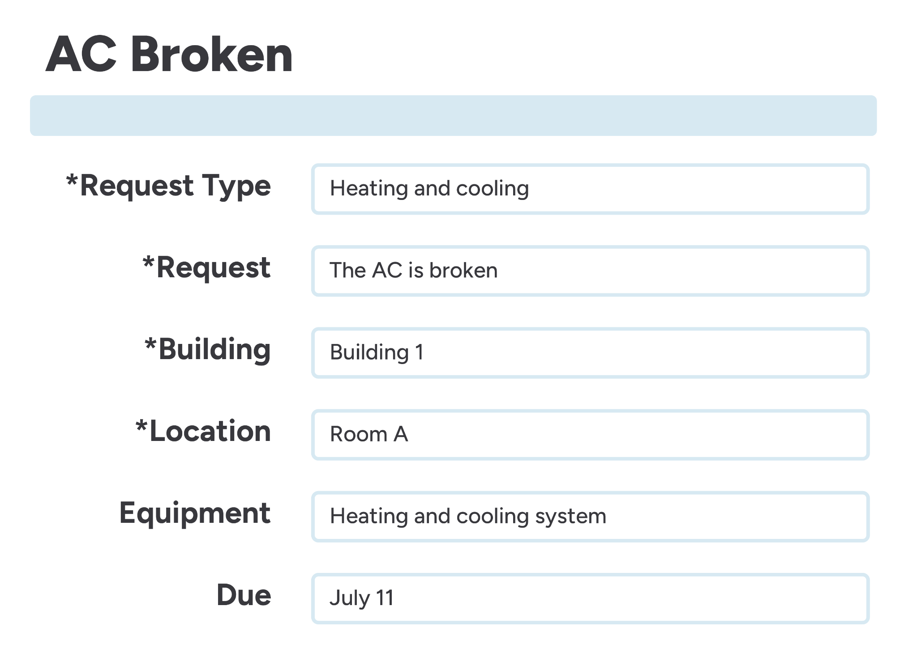 | Centralize your work order process with innovative, easy-to-use software.  Discover a smarter workflow with FMX

Organization Name  Street address  City, State 11101  (123) 456-7890  Email address | 

Cleaning Work Order
Work order information |  |  | Work location
Work order # |  |  | Address
Priority level
Date issued
Assigned to |  |  | Building
Requested by |  |  | Room #

Work details |  |  |  |  | Expenses
Description of work |  |  |  |  | Parts and materials | Part # | Qty | Amount
 |  |  |  |  | Parts and materials total
 |  |  |  |  | Labor | Hours | Rate | Amount
 |  |  |  |  | Labor total
Work status |  |  | Custodian notes |  | Parts and materials total
 | Complete |  |  |  | Other
 | Not complete |  |  |  | Tax
 |  |  |  |  | Total

Supervisor approval
Name | Signature | Date

