Graphic Design  Request Template  A blank template can be found on page two. | 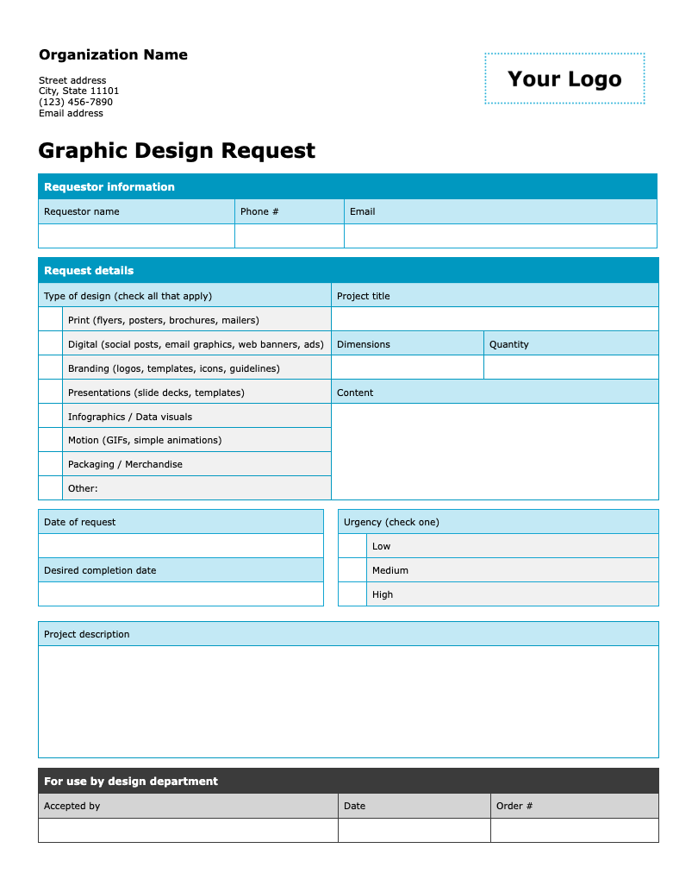

Follow these steps to get started

- Update the organization information by replacing the placeholder text with your organization's name, address, phone number, and email address.
- Add your logo by clicking on “Your Logo.” Then go to Insert > Picture and select the file you want to upload. The new image will automatically replace the placeholder.
- Adjust the fields and options on the form as needed.
- Remove this instruction page and distribute a copy to your colleagues to fill out and submit.

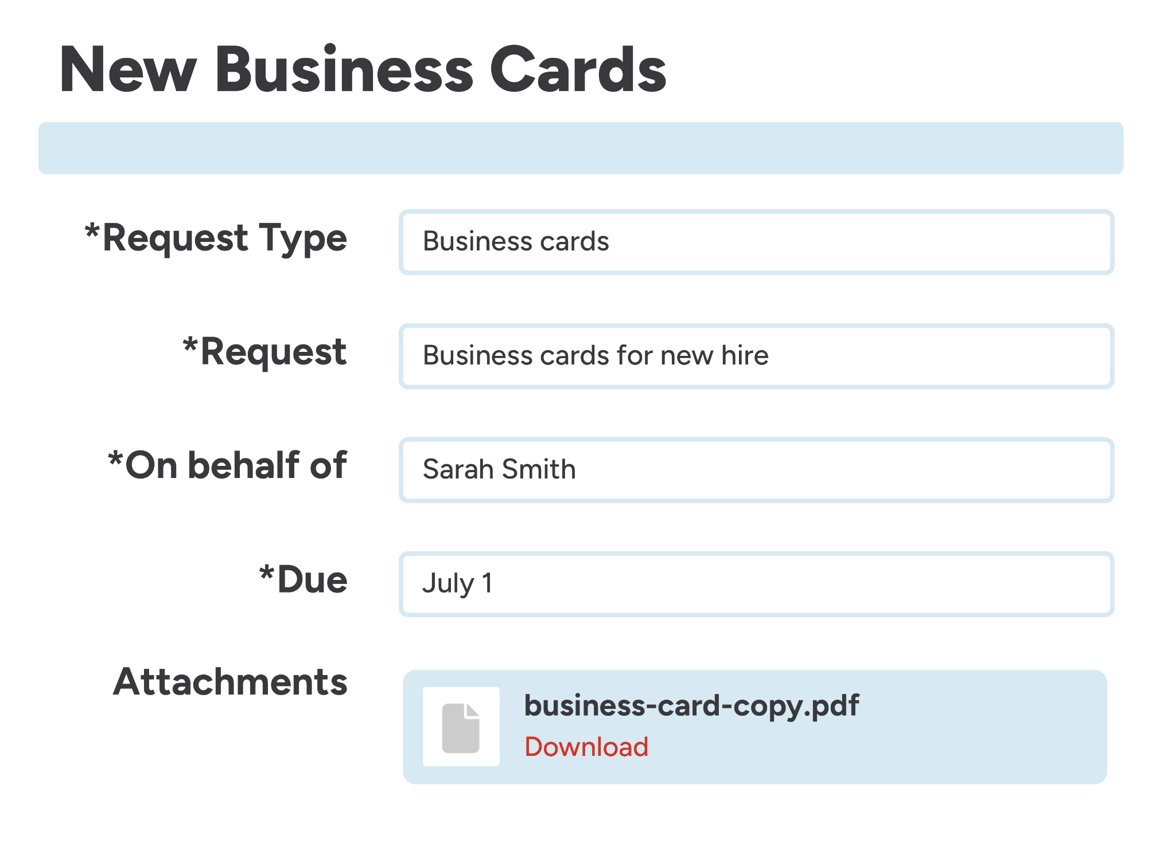 | Centralize your work order process with innovative, easy-to-use software.  Discover a smarter workflow with FMX

Organization Name  Street address  City, State 11101  (123) 456-7890  Email address | 

Graphic Design Request
Requestor information
Requestor name | Phone # | Email

Request details
Type of design (check all that apply) |  | Project title
 | Print (flyers, posters, brochures, mailers)
 | Digital (social posts, email graphics, web banners, ads) | Dimensions | Quantity
 | Branding (logos, templates, icons, guidelines)
 | Presentations (slide decks, templates) | Content
 | Infographics / Data visuals
 | Motion (GIFs, simple animations)
 | Packaging / Merchandise
 | Other:

Date of request |  | Urgency (check one)
 |  |  | Low
Desired completion date |  |  | Medium
 |  |  | High

Project description

For use by design department
Accepted by | Date | Order #

