Marketing  Request Template  A blank template can be found on page two. | 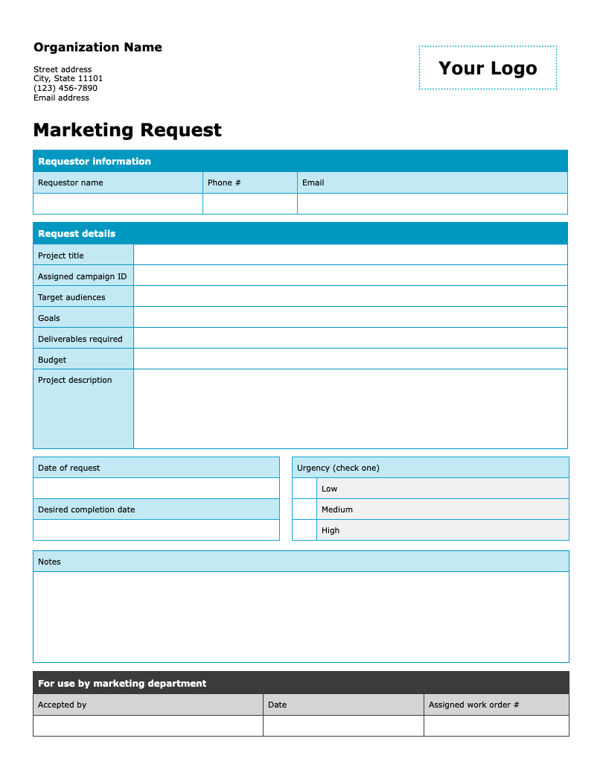

Follow these steps to get started

- Update the organization information by replacing the placeholder text with your organization's name, address, phone number, and email address.
- Add your logo by clicking on “Your Logo.” Then go to Insert > Picture and select the file you want to upload. The new image will automatically replace the placeholder.
- Adjust the fields and options on the form as needed.
- Remove this instruction page and distribute a copy to your colleagues to fill out and submit.

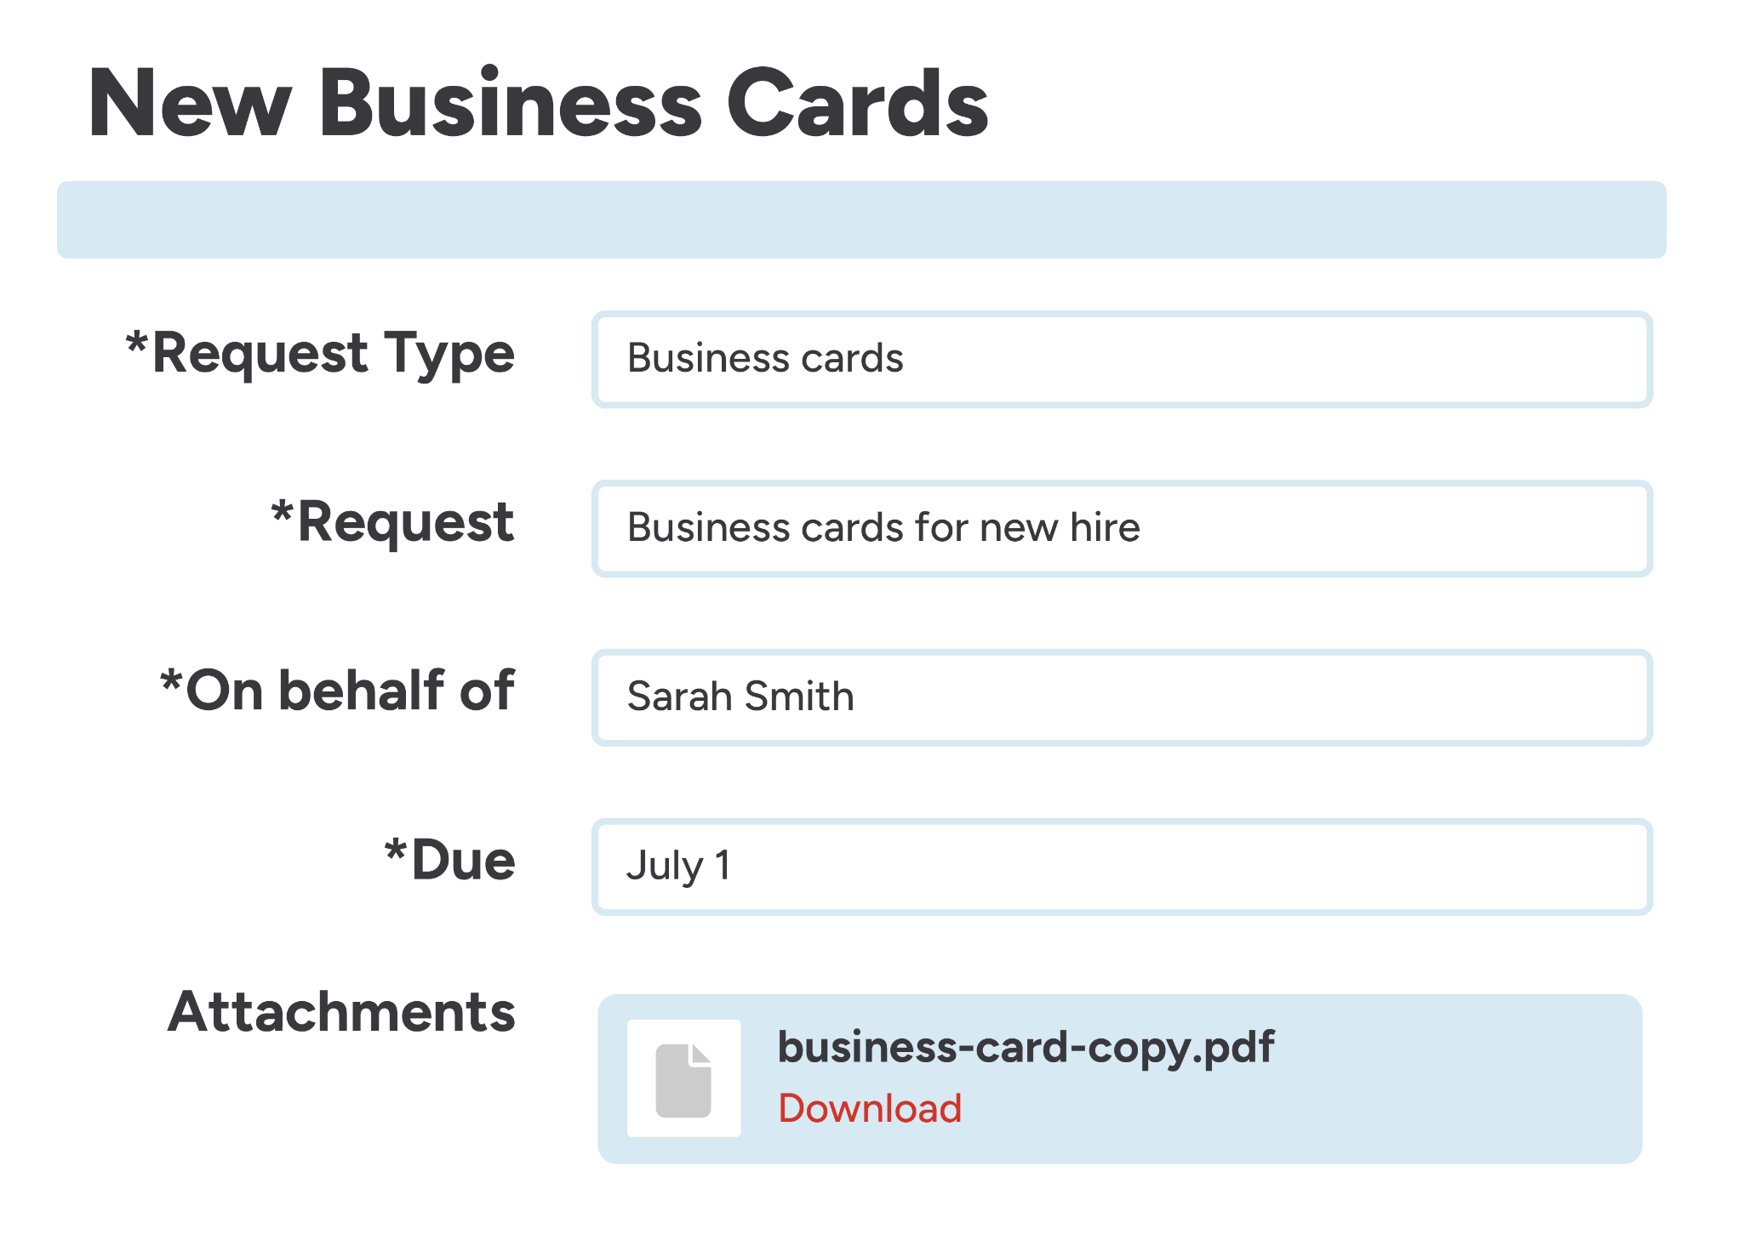 | Centralize your work order process with innovative, easy-to-use software.  Discover a smarter workflow with FMX

Organization Name  Street address  City, State 11101  (123) 456-7890  Email address | 

Marketing Request
Requestor information
Requestor name | Phone # | Email

Request details
Project title
Assigned campaign ID
Target audiences
Goals
Deliverables required
Budget
Project description

Date of request |  | Urgency (check one)
 |  |  | Low
Desired completion date |  |  | Medium
 |  |  | High

Notes

For use by marketing department
Accepted by | Date | Assigned work order #

