Work Order Request Template  A blank template can be found on page two. | 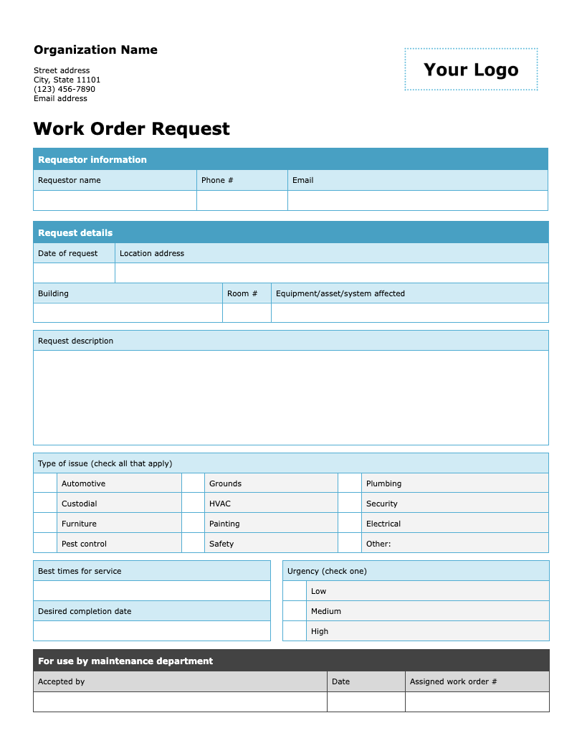

Follow these steps to get started

- Update the organization information by replacing the placeholder text with your organization's name, address, phone number, and email address.
- Add your logo by clicking on “Your Logo.” Then go to Insert > Picture and select the file you want to upload. The new image will automatically replace the placeholder.
- Adjust the fields and options on the form as needed.
- Remove this instruction page and distribute a copy to your colleagues to fill out and submit.

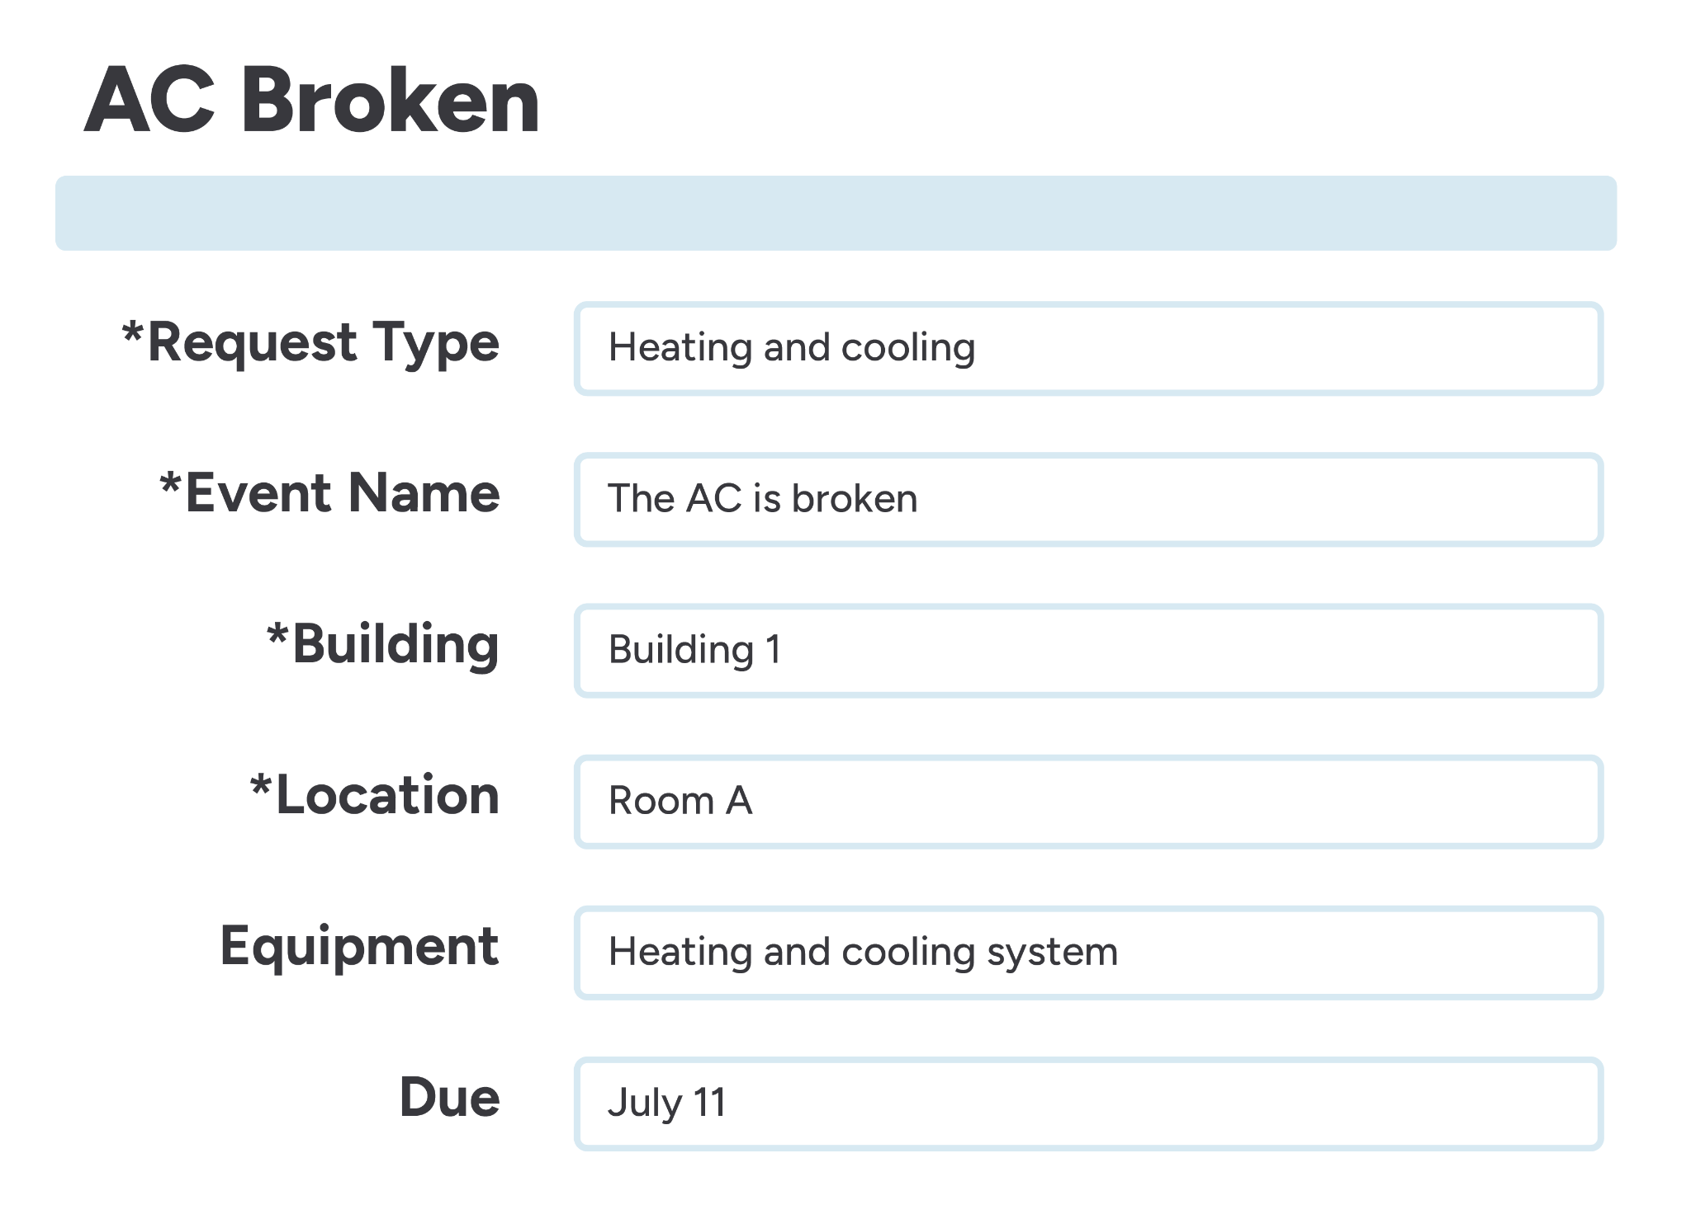 | Centralize your work order process with innovative, easy-to-use software.  Discover a smarter workflow with FMX

Organization Name  Street address  City, State 11101  (123) 456-7890  Email address | 

Work Order Request
Requestor information
Requestor name | Phone # | Email

Request details
Date of request | Location address
Building |  | Room # | Equipment/asset/system affected

Request description

Type of issue (check all that apply)
 | Automotive |  | Grounds |  | Plumbing
 | Custodial |  | HVAC |  | Security
 | Furniture |  | Painting |  | Electrical
 | Pest control |  | Safety |  | Other:

Best times for service |  | Urgency (check one)
 |  |  | Low
Desired completion date |  |  | Medium
 |  |  | High

For use by maintenance department
Accepted by | Date | Assigned work order #

